Kristin Briggs

**BSC6926**  – Spring 2020

Final Project: Regression analysis and non-linear model fit of periphyton inorganic carbon content vs. water depth and TP, across regions

**Introduction**

The precipitation of calcium carbonate minerals (CaCO3) is a widespread process in aquatic ecosystem, key throughout our geological history by building soils, sedimentary rock (storing carbon) and by influencing global carbon fluxes. At the microscopic level, this precipitation occurs in various ways and is often caused by biological activity of cyanobacteria and other microbes in complex interactions with physical conditions and water chemistry (eg. pH, DOC). In the South FL Everglades, microbial mats (or periphyton) play important roles in the ecosystem, are highly productive and precipitate large amounts of CaCO3 on a landscape-scale, and thereby may drive carbon fluxes of the system. Conditions (eg. water chemistry, hydrology) vary over this low-nutrient, flood-pulsed wetland, so understanding how these variations influence CaCO3 precipitation is important to evaluating carbon fluxes. It may also be insightful into drivers of cyanobacterial calcification occurring in other oligotrophic, karstic systems which are comparable to ancient stromatolite-forming communities. Cyanobacterial calcification has great potential application for carbon capture and storage (CCS) technologies and is important to our understanding of carbon fluxes in freshwater and marine systems.

A regression analysis and non-linear model fitting will be performed to evaluate the influence of environmental variables on this important microbially-driven process. A hydrological variable, water depth, and water chemistry variable, total phosphorus (TP), will be evaluated against inorganic carbon content (ash weight, an approximate measure of calcium carbonate precipitation), since these variables can both influence the biological processes involved in CaCO3 precipitation. For instance, water depth may influence temperature, ion concentrations, irradiance thereby photosynthesis (increasing pH), and/or limit gas diffusion (CO2) into the water column possibly augmenting DOC equilibrium. Phosphorus availability also influences precipitation processes indirectly, for example by stimulating heterotrophic metabolism, which decreases pH encouraging CaCO3 breakdown. Both these variables, water depth and phosphorus, also shape the composition of the algal and/or microbial community itself, so changes in the calcifying species presence and activity may be influential. Another important variable, region, is spatially implicit and represents areas of different landscape features, hydrology, management regime/intensity, chemistry, and more. Many of these factors, which vary regionally, may influence carbonate precipitation processes, by augmenting the local conditions and biological interactions within the periphyton. Since this dataset is well resolved at the landscape scale, measurements are replicated per site, and periphyton samples are collected simultaneously, this gives us the opportunity to assess environmental drivers of a microbial process that sustains/drives ecosystem functioning. Furthermore, the Everglades water flow is heavily managed and large-scale modifications are ongoing to restore surface flow and improve ecosystem functioning, but the impacts of these efforts are still being studied. Evaluating how CaCO3 precipitation is influenced by these major environmental factors may help us predict consequences of hydrologic and water chemistry shifts on carbon budget and Everglades functioning. My hypothesis is that water depth and total phosphorus will both be good predictors of ash weight, and that region will have a strong relationship with water depth.

**Methods & Data:** Samples and environmental data collected annually for the Comprehensive Everglades Restoration Plan (CERP MAP) from approximately 130 sites across the Everglades landscape. Includes: periphyton and water samples analyzed in the lab for nutrients, biomass, communitycomposition, & more. Environmental and water chemistry variables include water depth, total phosphorus, conductivity, pH, soil depth, soil type, and more. These measurements were replicated 3 times per site and averaged. Periphyton/microbial mat samples were analyzed in the lab for nutrients and biomass, including organic matter content (ash-free dry weight) and inorganic carbon (ash weight). Ash weight is used as a reliable estimate of calcium carbonate content/precipitation, since the inorganic portion of the periphyton is almost all calcium carbonate. Regression analyses to evaluate how hydrology and water chemistry predict inorganic carbon content (ash weight) will be performed: models will include ash weight vs. water depth (continuous), vs. TP (continuous) and water depth vs. region (categorical).Residual plots and normality tests performed to evaluate model assumptions. Log transformation is used on response variable (ash weight) to improve linear regression fit. Variance inflation factor used for collinearity measure and ANOVA to compare model fits. Bootstrap was attempted to evaluate the water depth or ash weight by region. A non-linear model, Weibull distribution function, was attempted to fit to the data.

**Results**

There is a strong effect of region on water depth (p<2e^-16), as the graph shows significant differences in the mean and variation between regions (Fig. 3). Scatterplots show the relationship between ash weight and both water depth (Fig. 1a) and TP (Fig. 2a) have a non-linear relationship which seems logarithmic, or in a Weibull distribution; after log transforming data, both display a more linear relationship (Figure 1&2b). Residual plots show that raw data is not normally distributed (QQ plots) and could be non-linear (Fig.4), which is supported by Shapiro tests (all p-values <0.0001; Fig. 6a). Normality of distribution was achieved in model m1 and m3 after log tranformation of the response variable, but the models still displayed some skewness (Fig. 5). Using simple linear models with raw ash weight calculated a weak linear trend with both water depth (R2 = 0.1535) and TP (adj R2 = 0.189). After log transforming the response variable (ash weight), both relationships were notably improved: water depth R2 increased to 0.275, and the combined model with water depth + TP increased to adjusted R2 of 0.532. Introducing region to the model did not improve the model fit (p<1.46e^-8) as much as TP (p<2e^-16). Combining water depth and TP against log transformed ash weight gave the best fit, with a negative linear relationship explaining more than half the variation (p-value<2e^-16, R = -0.642, Res.SE=1.684, df=604). An ANOVA test comparing models confirmed best fit was model LM2. Co-linearity between TP and water depth seemed like it could be an issue (p-value =0.00024; R2 = 0.029), but these variables are influenced by some of the same factors in the field and are still functionally and dynamically independent of each other. Variation inflation factor test confirmed there is little inflation/collinearity between TP and water depth. Attempts to use a Weibull self-start function for a non-linear model were not successful. Initial values for this function included: the horizontal asymptote, drop, natural log of rate constant, and power x is raised. These values were chosen based on the scatterplot of data, but I couldn’t figure out exactly how to calculate them by hand or with code or derive them from the graph (Fig. 7a). Graph of predicted values doesn’t match the data, as the initial values didn’t work or fit the model as they were chosen. Bootstrap non-parametric analysis was conducted for the models including ash weight vs. region, depth, and tp + depth. The t-values don’t seem to make sense, as the analysis didn’t generate bias or standard error values. I believe something was wrong with the response variable having NA or 0 values, but I couldn’t get the bootstrap to work even after fixing this.

**Discussion**

In conclusion, my hypothesis that both water depth and TP were good predictors of periphyton ash weight (or inorganic carbon/calcium carbonate content), was supported by the analysis, but further investigation is needed. The influence of region is still not fully resolved, so analysis into variations between regional conditions will be prudent. Since both these variables (water depth and TP) effect the biological activity of microbial mats which cause calcification, exploring how they affect calcification on the meso- or microscopic scale is necessary to pinpoint important environmental and/or biological factors. A combination of laboratory microcosm and field mesocosm experiments on periphyton calcium carbonate precipitation would help answer questions about carbonate dynamics and cyanobacterial calcification in oligotrophic systems in general. Considering the environmental gradients of this vast wetland, analyses performed separated by region may be prudent since periphyton community, functioning and calcification may occur differently under regional conditions. The application of a Weibull distribution model may enable a better fit to the overall regression, as it is commonly used to model natural processes and seems to fit the data distribution of both influential variables (water depth and TP). Water depth can be related to many important physical conditions, like water column pressure that limit gas exchange and ionic content of the water, but also indirectly related to various factors since water depth helps shape the biological community, which in turn define the systems chemistry. Since the Everglades has been undergoing large scale dredging which increased groundwater input and modified ionic composition, evaluating the water’s ionic content (against periphyton ash weight) could be informative. Other variables like conductivity, DOC, pH and various biological factors should be compared between regions or in other analyses. Experiments with periphyton using these variables, paired with landscape/observational studies may be very insightful into calcification drivers, carbon fluxes, and help resolve our understanding of processes at the landscape scale.

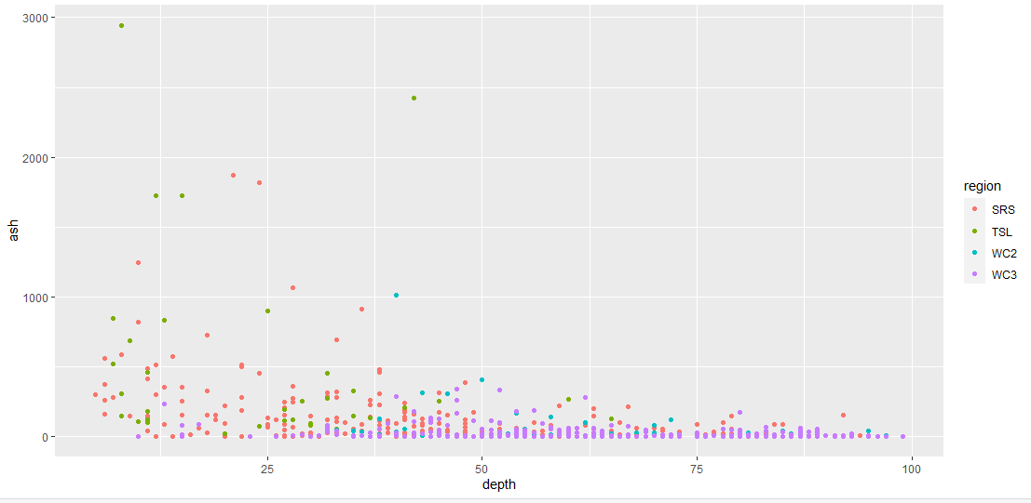

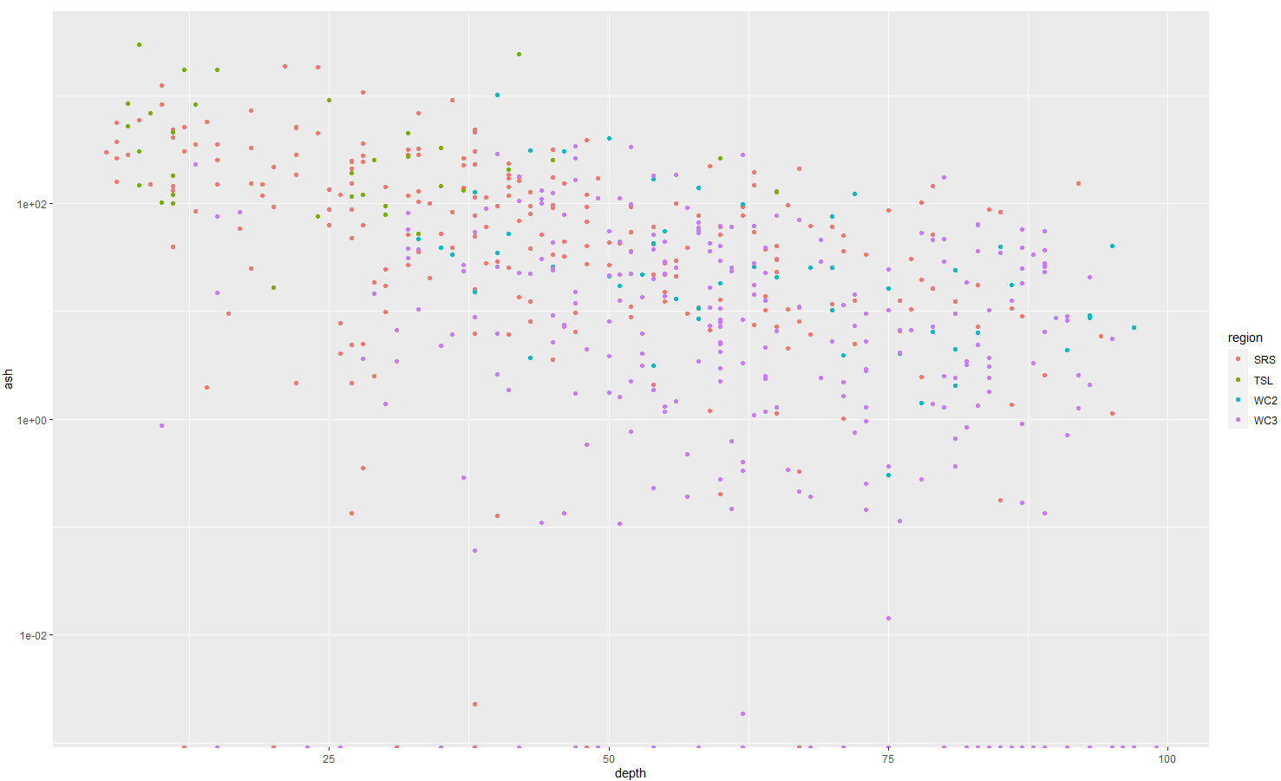

Figure 1: top graphs inorganic carbon/ash weight against water depth with no transformation. Bottom graph shows the same data with ash weight on log transformed scale. Regions are indicated by colored dots.

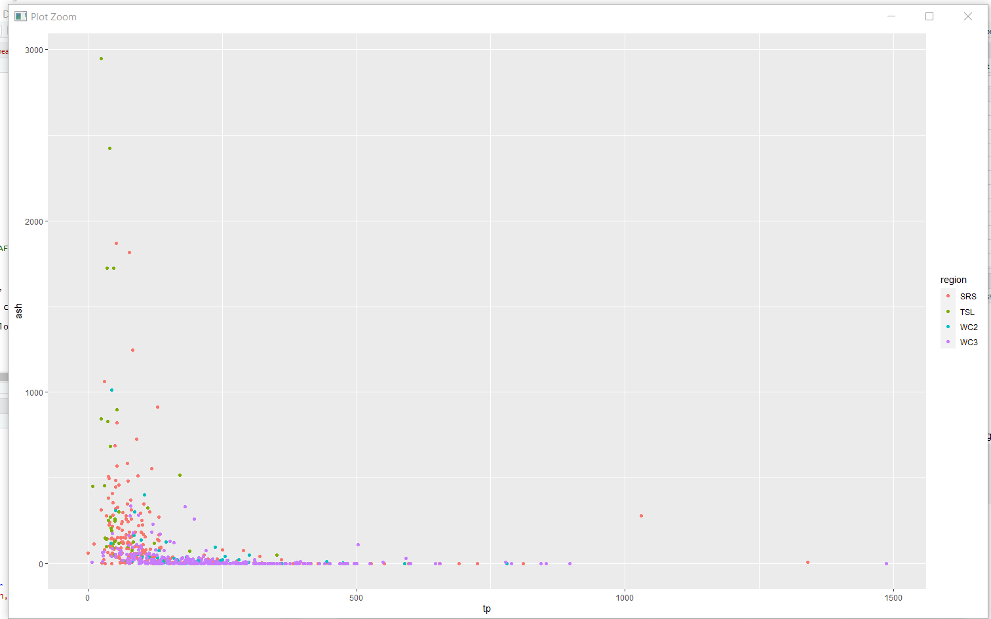

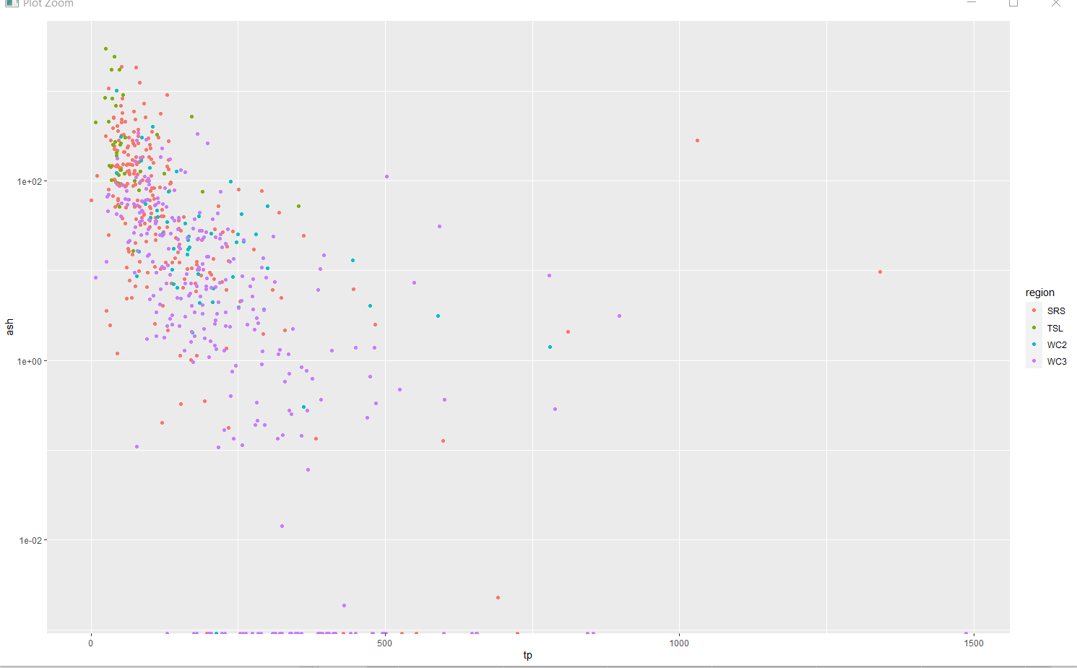

Figure 2: top graphs inorganic carbon/ash weight against total phosphorus with no transformation. Bottom graph shows the same data with ash weight on log transformed scale. Regions are indicated by colored dots.

a.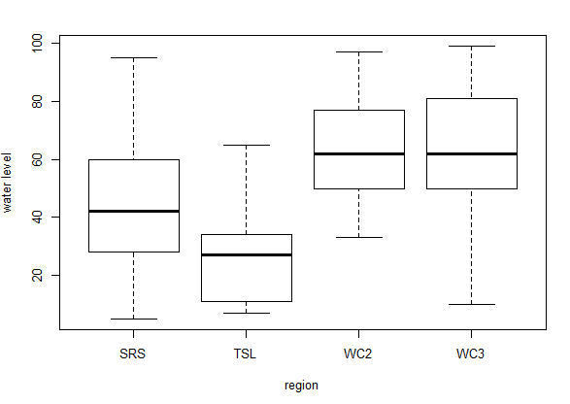b. 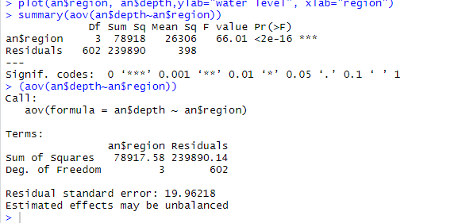

Figure 3: Water depths by region.

a.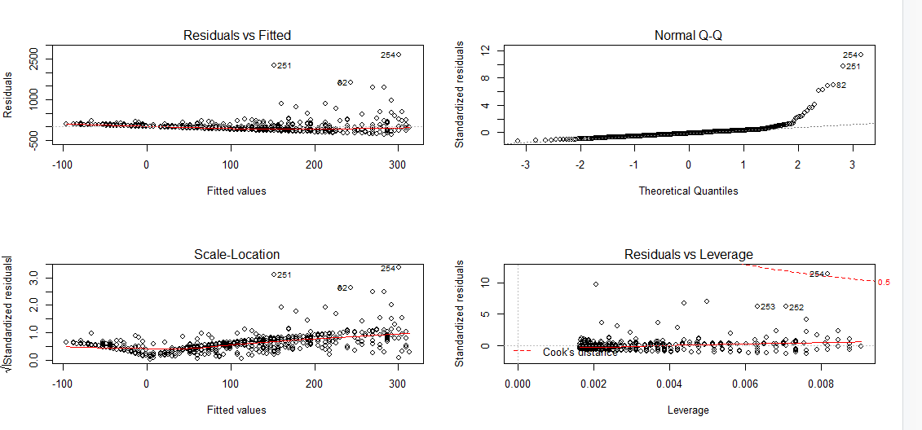

b. 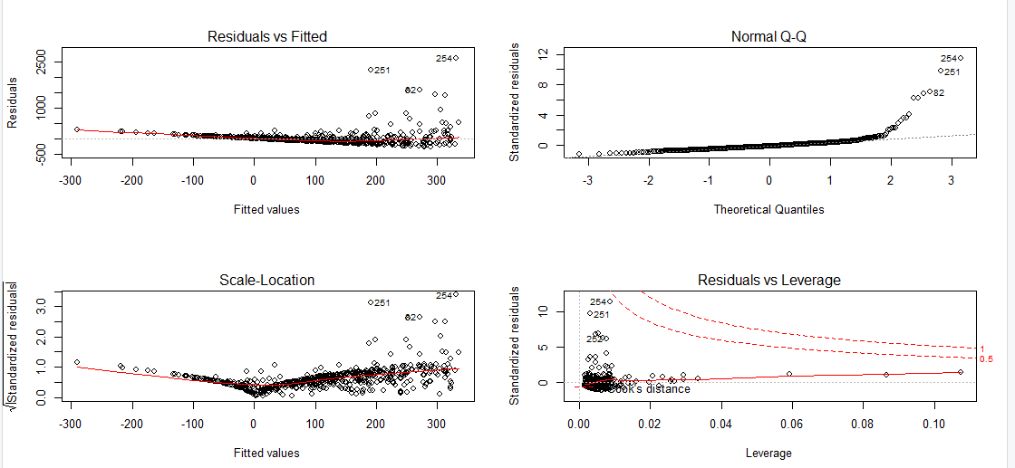

c. 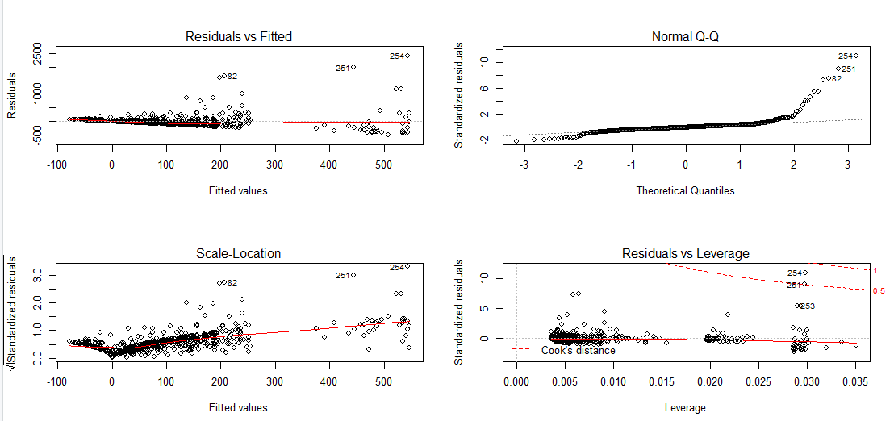

Figure 4: Residual plots for evaluating model assumptions, models being plotted are a) ash weight vs. depth, b) vs. depth + TP, c) vs. depth + region.

a.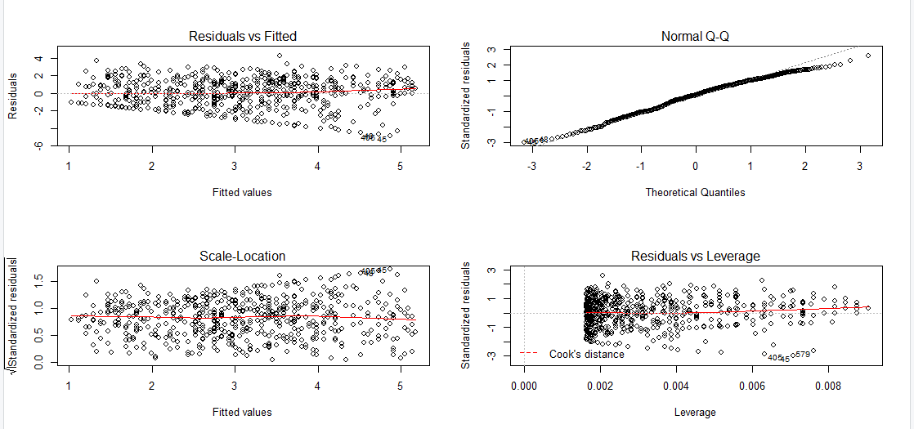

b.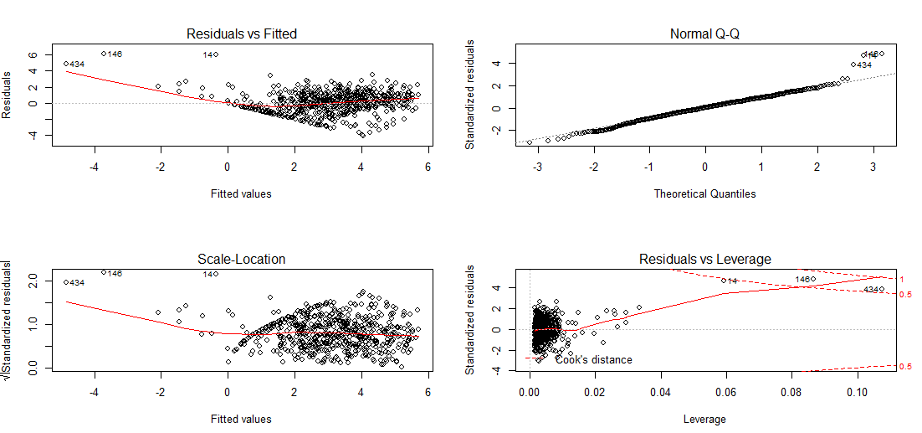

c.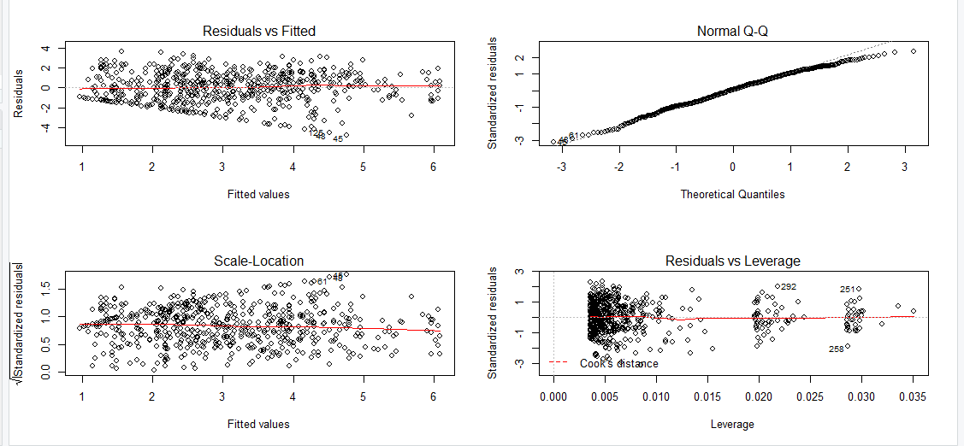

Figure 5: Residual plots after ash weight was log transformed. models being plotted are a) ash weight vs. depth, b) vs. depth + TP, c) vs. depth + region.

1. 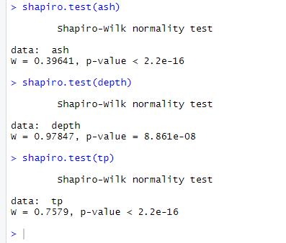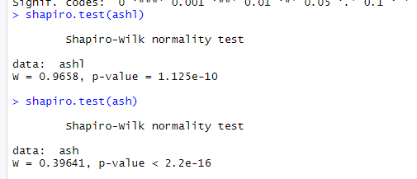 b.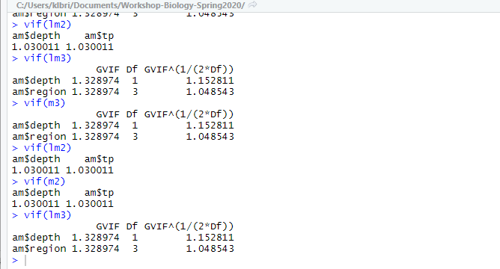

Figure 6: a. Shapiro tests all failed to reject the null hypothesis that data was normally distributed, for all variables. Some p-values were much lower than others, which could mean the larger p-values were from datasets closer to normally distributed. B. Variance inflation factor shows there isn’t high collinearity between variables.

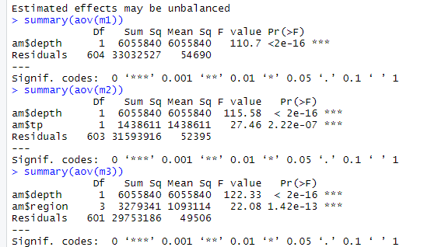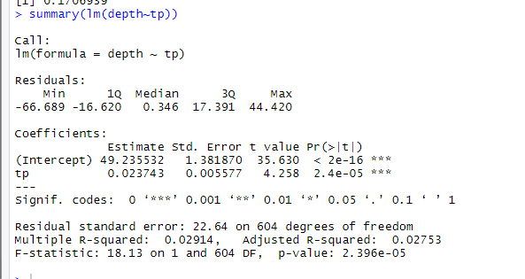

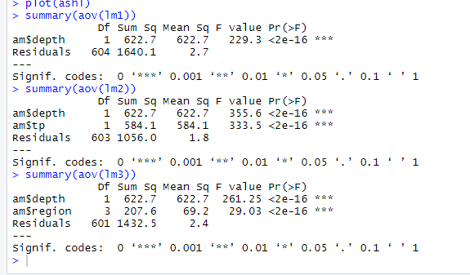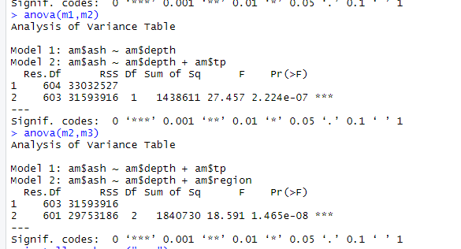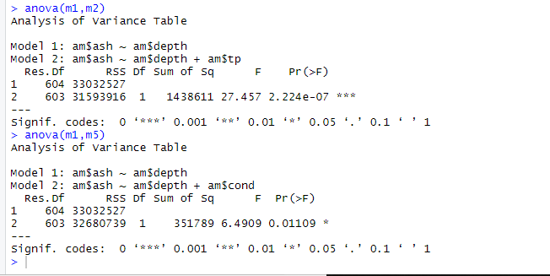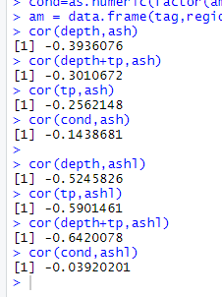

Figure 7: Anova tables for models (M1 ash weight vs. depth, M2 ash weight vs. depth + TP, M3 ash weight vs. depth +region; LM1 log(ash weight + 1) vs. depth, LM2 log(ash weight + 1) vs. depth + TP, LM3 log(ash weight + 1) vs. depth +region.

1. 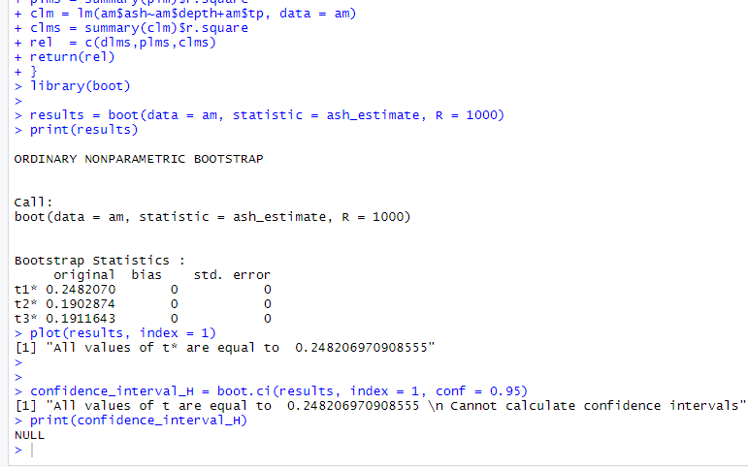

b. 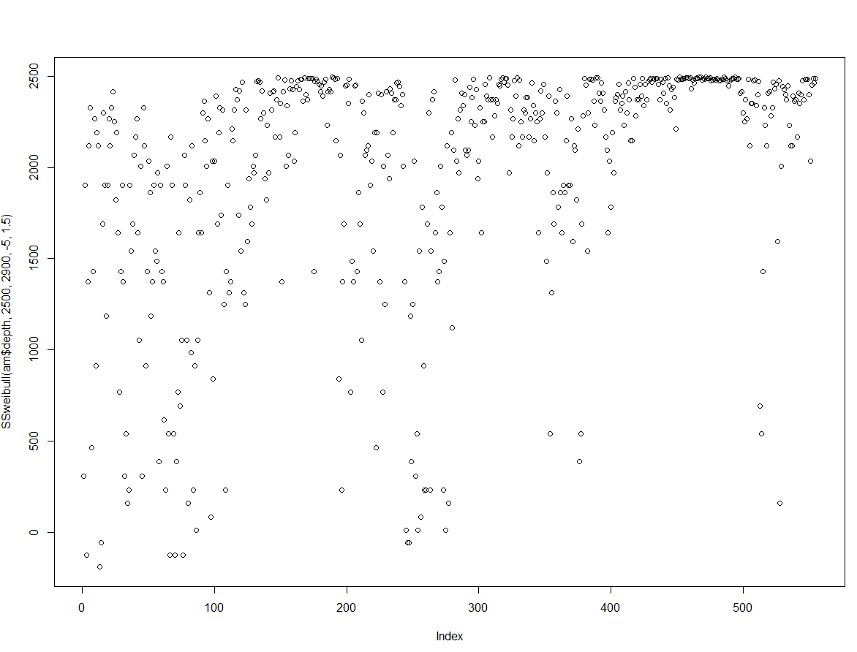

> getInitial(am$depth ~ SSweibull(am$depth, Asym, Drop, lrc, pwr), data = am)

Error in nls(y ~ cbind(1, -exp(-exp(lrc) * x^pwr)), data = xy, algorithm = "plinear", :

step factor 0.000488281 reduced below 'minFactor' of 0.000976562

> y=am$ash

> summary(aov(am$depth~am$region))

Df Sum Sq Mean Sq F value Pr(>F)

> ### nls models

> ## Initial values are in fact the converged values

> fm1 <- nls(y ~ SSweibull(am$depth, 3000, 2900, -5, 1.5), data = am)

Error in lm.fit(x, y, offset = offset, singular.ok = singular.ok, ...) :

0 (non-NA) cases

In addition: Warning message:

In log((Rasym - y)/(Rasym - Lasym)) : NaNs produced

> summary(fm1)

Error in summary(fm1) : object 'fm1' not found

Figure 8: a. Bootstrap results for three models, ash weight vs. region; depth; and tp + depth. The t-values don’t seem to make sense, as the analysis didn’t generate bias or standard error values. b. Non-linear model with a Weibull distribution function. Graph of predicted values doesn’t match the data, as the initial values didn’t work or fit the model as they were chosen.

**REFERENCES**

Bellinger, B. J., Gretz, M. R., Domozych, D. S., Kiemle, S. N., & Hagerthey, S. E. (2010). Composition Of Extracellular Polymeric Substances From Periphyton Assemblages In The Florida Everglades. *Journal of Phycology,* *46*(3), 484-496. doi:10.1111/j.1529-8817.2010.00829.x

Benzerara, K., Skouri-Panet, F., Li, J., Ferard, C., Gugger, M., Laurent, T., . . . Moreira, D. (2014). Intracellular Ca-carbonate biomineralization is widespread in cyanobacteria. *Proceedings of the National Academy of Sciences,* *111*(30), 10933-10938. doi:10.1073/pnas.1403510111

Brady, A. L., Druschel, G., Leoni, L., Lim, D. S., & Slater, G. F. (2013). Isotopic biosignatures in carbonate-rich, cyanobacteria-dominated microbial mats of the Cariboo Plateau, B.C. *Geobiology,* *11*(5), 437-456. doi:10.1111/gbi.12050

Chacon, E. (2010). Microbial mats as a source of biosignatures. In J. Seckbach & A. Oren (Authors), *Microbial mats: Modern and ancient microorganisms in stratified systems* (pp. 151-158). Dordrecht/NY: Springer.

Childers, D. L., Boyer, J. N., Davis, S. E., Madden, C. J., Rudnick, D. T., & Sklar, F. H. (2006). Relating precipitation and water management to nutrient concentrations in the oligotrophic “upside‐down” estuaries of the Florida Everglades. Limnology and Oceanography, 51(1part2), 602–616. doi: 10.4319/lo.2006.51.1_part_2.0602

Couradeau, E., Benzerara, K., Gérard, E., Estève, I., Moreira, D., Tavera, R., & López-García, P. (2013). Cyanobacterial calcification in modern microbialites at the submicrometer-scale. *Biogeosciences Discussions,* *10*(2), 3311-3339. doi:10.5194/bgd-10-3311-

Dittrich, M., & Sibler, S. (2010). Calcium carbonate precipitation by cyanobacterial polysaccharides. *Geological Society, London, Special Publications,* *336*(1), 51-63. doi:10.1144/sp336.4

Dodds, W. K. (2003). The role of periphyton in phosphorus retention in shallow freshwater aquatic systems. *Journal of Phycology,* (39), 840-849.

Dupraz, C., Reid, R. P., Braissant, O., Decho, A. W., Norman, R. S., & Visscher, P. T. (2009). Processes of carbonate precipitation in modern microbial mats. *Earth-Science Reviews,* *96*(3), 141-162. doi:10.1016/j.earscirev.2008.10.005

Echenique-Subiabre, I., Villeneuve, A., Golubic, S., Turquet, J., Humbert, J. F., & Gugger, M. (2014). Influence of local and global environmental parameters on the composition of cyanobacterial mats in a tropical lagoon. *Microbial Ecology*, *69*(2), 234–244.

Gaiser, E. E., A. Wachnicka, P. Ruiz, F. A. Tobias & M. S. Ross. (2004). Diatom indicators of ecosystem change in coastal wetlands. In S. Bortone (Ed.) *Estuarine Indicators*. CRC

Press, Boca Raton, FL. pp. 127-144.

Gaiser, E., Hée, J. M., Tobias, F. A., & Wachnicka, A. H. (2010). Mastogloia smithii var lacustrisGrun.: A Structural Engineer of Calcareous Mats in Karstic Subtropical Wetlands. *Proceedings of the Academy of Natural Sciences of Philadelphia,* *160*(1), 99-112. doi:10.1635/053.160.0111

Gerdes, G., (2010). What are microbial mats? In J. Seckbach (Author), *Microbial mats : Modern and ancient microorganisms in stratified systems* (pp. 5-21). Dordrecht/NY: Springer.

Gaiser, E. E., J. C. Trexler, J. H. Richards, D. L. Childers, D. Lee, A. L. Edwards, L. J. Scinto, K. Jayachandran, G. B. Noe & R. D. Jones. (2005). Cascading ecological effects of low-level phosphorus enrichment in the Florida Everglades. *Journal of Environmental*

*Quality* 34: 717-723.

Gaiser, E. E., Childers, D. L., Jones, R. D., Richards, J. H., Scinto, L. J., & Trexler, J. C. (2006). Periphyton responses to eutrophication in the Florida Everglades: Cross-system patterns of structural and compositional change. *Limnology and Oceanography*, *51*(1,2), 617–630.

Gaiser, E. (2009). Periphyton as an indicator of restoration in the Florida Everglades. *Ecological Indicators,* *9*(6).

Gaiser, E. E., Mccormick, P. V., Hagerthey, S. E., & Gottlieb, A. D. (2011). Landscape Patterns of Periphyton in the Florida Everglades. *Critical Reviews in Environmental Science and Technology,* *41*(Sup1), 92-120. doi:10.1080/10643389.2010.531192

Gaiser, E. E., Sullivan, P., Tobias, F. A. C., Bramburger, A. J., & Trexler, J. C. (2014) Boundary Effects on Benthic Microbial Phosphorus Concentrations and Diatom Beta Diversity in a Hydrologically-modified, Nutrient-limited Wetland. *Wetlands.34(Supp 1),*(S55-S64)

Gottlieb, A., Richards, J., & Gaiser, E. (2005). Effects of desiccation duration on the community structure and nutrient retention of short and long-hydroperiod Everglades periphyton mats. *Aquatic Botany*, *82*(2), 99–112.

Gottlieb, A. D., Richards, J. H., & Gaiser, E. E. (2006). Comparative study of periphyton community structure in long and short-hydroperiod Everglades marshes. *Hydrobiologia*, *569*(1), 195–207.

Gray, C. J., & Engel, A. S. (2012). Microbial diversity and impact on carbonate geochemistry across a changing geochemical gradient in a karst aquifer. *The ISME Journal,* *7*(2), 325-337. doi:10.1038/ismej.2012.105

Hagerthey, S. E., Bellinger, B. J., Wheeler, K, Gantar, M & Gaiser, E. (2011) Everglades Periphyton: A Biogeochemical Perspective, Critical Reviews in Environmental Science and Technology, 41:S1, 309-343.

Hagerthey, S. E., Newman, S., Rutchey, K., Smith, E. P., & Godin, J. (2008). Multiple Regime Shifts In A Subtropical Peatland: Community-Specific Thresholds To Eutrophication. *Ecological Monographs,* *78*(4), 547-565. doi:10.1890/07-0538.1

Inglett, P., Reddy, K., & Mccormick, P. (2004). Periphyton chemistry and nitrogenase activity in a northern Everglades ecosystem. *Biogeochemistry,* *67*(2), 213-233. doi:10.1023/b:biog.0000015280.44760.9a

Jansson, C., & Northen, T. (2010). Calcifying cyanobacteria—the potential of biomineralization for carbon capture and storage. *Current Opinion in Biotechnology,* *21*(3), 365-371. doi:10.1016/j.copbio.2010.03.017

Kamennaya, N., Ajo-Franklin, C., Northen, T., & Jansson, C. (2012). Cyanobacteria as Biocatalysts for Carbonate Mineralization. *Minerals,* *2*(4), 338-364. doi:10.3390/min2040338

Kayranli, B., Scholz, M., Mustafa, A., & Hedmark, Å. (2009). Carbon Storage and Fluxes within Freshwater Wetlands: A Critical Review. *Wetlands,* *30*(1), 111-124. doi:10.1007/s13157-009-0003-4

Kaźmierczak, J., Fenchel, T., Kühl, M., Kempe, S., Kremer, B., Łącka, B., & Małkowski, K. (2015). CaCO3 Precipitation in Multilayered Cyanobacterial Mats: Clues to Explain the Alternation of Micrite and Sparite Layers in Calcareous Stromatolites. *Life,* *5*(1), 744-769. doi:10.3390/life5010744

Komárek, J., Sirová, D., Komárková, J., & Rejmánková, E. (2015). Structure and Function of Cyanobacterial Mats in Wetlands of Belize. *Microbiology of the Everglades Ecosystem,* 194-217. doi:10.1201/b18253-13

Ludwig, R., Al-Horani, F. A., Beer, D. D., & Jonkers, H. M. (2005). Photosynthesis-controlled calcification in a hypersaline microbial mat. *Limnology and Oceanography,* *50*(6), 1836-1843. doi:10.4319/lo.2005.50.6.1836

Marazzi, L. E., Gaiser, E., Tobias, F.A.C. (2017). Phosphorus scarcity and desiccation stress increase the occurrence of dominant taxa in wetland benthic primary producer communities. *Aquatic Ecology*, 51(4), 571-589.

**Marazzi, L., Gaiser, E.E.**, Jones, V.J., **Tobias, F.A.,** and Mackay, A.W. (2017). [Algal richness and life‐history strategies are influenced by hydrology and phosphorus in two major subtropical wetlands](http://onlinelibrary.wiley.com/doi/10.1111/fwb.12866/full). *Freshwater Biology* 62:274-290.

Mazzei, V., & Gaiser, E. (2018). Diatoms as tools for inferring ecotone boundaries in a coastal freshwater wetland threatened by saltwater intrusion. *Ecological Indicators,* *88*, 190-204. doi:10.1016/j.ecolind.2018.01.003

McCormick, P. V., Newman, S., & Vilchek, L. W. (2008). Landscape responses to wetland eutrophication: Loss of slough habitat in the Florida Everglades, USA. *Hydrobiologia,* *621*(1), 105-114. doi:10.1007/s10750-008-9635-2

Mccormick, P. V., & Stevenson, R. J. (1998). Periphyton As A Tool For Ecological Assessment And Management In The Florida Everglades. Journal of Phycology, 34(5), 726–733. doi: 10.1046/j.1529-8817.1998.340726.x

McVoy, C. W. (2011). Landscapes and hydrology of the predrainage Everglades. Gainesville: University Press of Florida.

Merz, M. U. (1993). Biology of carbonate precipitation by cyanobacteria. *Facies,* *29*(1), 80-80. doi:10.1007/bf02536920

Newman, S., Osborne, T. Z., Hagerthey, S. E., Saunders, C., Rutchey, K., Schall, T., & Reddy, K. R. (2017). Drivers of landscape evolution: Multiple regimes and their influence on carbon sequestration in a sub-tropical peatland. *Ecological Monographs,* *87*(4), 578-599. doi:10.1002/ecm.1269

Noe, G. B., Scinto, L. J., Taylor, J., Childers, D. L., & Jones, R. D. (2003). Phosphorus cycling and partitioning in an oligotrophic Everglades wetland ecosystem: a radioisotope tracing study. Freshwater Biology, 48(11), 1993–2008. doi: 10.1046/j.1365-2427.2003.01143.x

Obst, M., Wehrli, B., & Dittrich, M. (2009). CaCO3 nucleation by cyanobacteria: Laboratory evidence for a passive, surface-induced mechanism. *Geobiology,* *7*(3), 324-347. doi:10.1111/j.1472-4669.2009.00200.x

Omelon, C. R., Brady, A. L., Slater, G. F., Laval, B., Lim, D. S., & Southam, G. (2013). Microstructure variability in freshwater microbialites, Pavilion Lake, Canada. *Palaeogeography, Palaeoclimatology, Palaeoecology,* *392*, 62-70. doi:10.1016/j.palaeo.2013.08.017

Paerl, H. W., & Paul, V. J. (2012). Climate change: Links to global expansion of harmful cyanobacteria. Water Research, 46(5), 1349–1363. doi: 10.1016/j.watres.2011.08.002

Pentecost, A. (2017). Cyanobacteria–phosphate–calcite interactions in limestone (hardwater) streams of England. *Hydrobiologia,* *811*(1), 49-60. doi:10.1007/s10750-017-3280-6

Prieto-Barajas, C. M., Valencia-Cantero, E., & Santoyo, G. (2018). Microbial mat ecosystems: Structure types, functional diversity, and biotechnological application. *Electronic Journal of Biotechnology*, *31*, 48–56. <http://doi.org/10.1016/j.ejbt.2017.11.001>

Rastogi, R. P., Sonani, R. R., & Madamwar, D. (2014). The high-energy radiation protectant extracellular sheath pigment scytonemin and its reduced counterpart in the cyanobacterium Scytonema sp. R77DM. *Bioresource Technology*, *171*, 396–400. <http://doi.org/10.1016/j.biortech.2014.08.106>

Rejm´ankov, E., & Kom´arkov´a, J. (2000). A function of cyanobacterial mats in phosphorus-limited tropical wetlands. *Hydrobiologia,* (431), 135-153.

Reuter, M., Piller, W. E., Harzhauser, M., Kroh, A., & Berning, B. (2009). A Fossil Everglades-Type Marl Prairie And Its Paleoenvironmental Significance. *Palaios,* *24*(11), 747-755. doi:10.2110/palo.2009.p09-062r

Scinto, L., & Reddy, K. (2003). Biotic and abiotic uptake of phosphorus by periphyton in a subtropical freshwater wetland. *Aquatic Botany*, 77(3), 203–222. doi: 10.1016/s0304-3770(03)00106-2

Seckbach, J. & Oren, A. (2010). Microbial mats: modern and ancient microorganisms in stratified systems. Dordrecht New York: Springer.

Schneider, J., & Campion-Alsumard, T. L. (1999). Construction and destruction of carbonates by marine and freshwater cyanobacteria. *European Journal of Phycology,* *34*(4), 417-426. doi:10.1017/s0967026299002280

Stal, L. J. (2000). Cyanobacterial Mats and Stromatolites. In B. A. Whitton & M. Potts (Authors), *The ecology of cyanobacteria: Their diversity in time and space* (pp. 61-120). Boston/Dordrecht: Kluwer Academic.

Stevenson, J., Bothwell, M., Lowe, R., (1996). *Algal ecology: freshwater benthic ecosystems.* San Diego, CA. Academic Press.

Subhas, A. V., Adkins, J. F., Rollins, N. E., Naviaux, J., Erez, J., & Berelson, W. M. (2017). Catalysis and chemical mechanisms of calcite dissolution in seawater. *Proceedings of the National Academy of Sciences,* *114*(31), 8175-8180. doi:10.1073/pnas.1703604114

Zhu, T., & Dittrich, M. (2016). Carbonate Precipitation through Microbial Activities in Natural Environment, and Their Potential in Biotechnology: A Review. Frontiers in Bioengineering and Biotechnology, 4. doi: 10.3389/fbioe.2016.00004